**Theory of Knowledge Exhibition**

IBDP2-3 Stanley

The TOK prompt I have selected is: “**Can new knowledge change established values or beliefs?”.**  This exhibition explores this question by reflecting on knowledge and technology, and more specifically on how new scientific knowledge changes one’s original perception of science. I choose this prompt primarily because knowledge, especially scientific knowledge, is developing at a progressively higher rate. New technology is developed based on new knowledge, and it helps create new knowledge; therefore, it is vital to know whether new scientific knowledge can change established values or beliefs.

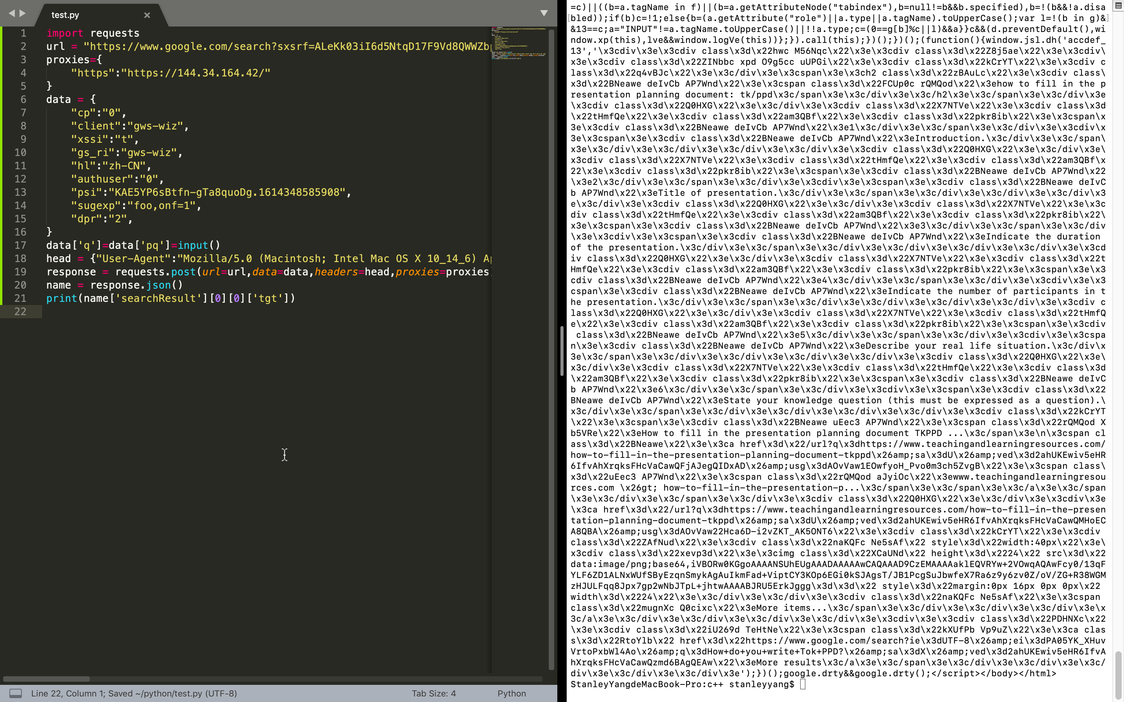**Object 1**: My Program that Crawls Webpage (source: the screenshot of my program and the output)

My first object is a program I have written by myself that connects to <http://google.com/> and automatically searches for relevant information on "TOK IA." It also scans the webpage source code, which is displayed on the right. By disguising itself as a human, this little program with dozens of lines can easily extract the web data without being detected. People originally believe that their own data is secure in their own local devices; nonetheless, this program can interact with website and extract other users’ data, however insignificant such data were, which contradicts with previous knowledge.

I chose this object because it refreshes people’s understanding on information dissemination. It has been widely believed that people's private information on the Internet would not be easy to acquire since it is kept well in their local devices. However, some developers created functions that interact with the internet automatically, and people’s local data can be leaked through their interaction with “bots” that pretend to be human users. Hackers with this technology can easily obtain user data, and people will be more aware of the potential threat to their privacy after more and more incidents of data leaks. Ordinary internet users’ conventional views on their online privacy are limited by the progression of technology; their beliefs are altered when better technology replaces prior ones despite the fact that most people never have received any formal education on internet privacy and the evolution of technology. Therefore, new scientific knowledge can change existing knowledge significantly.

However, for experts on information security, they may have already predicted some flaws of the current internet protocols. For instance, they may foresee the emergence of “bots” and design program-interaction features that further limit how automated programs can access their services. If the new scientific knowledge is within their prediction, then the new knowledge is not changing the established belief.

**Object 2**: Nicolaus Copernicus Observing the Universe

(*Nicolaus Copernicus, Polish astronomer*, 2021)

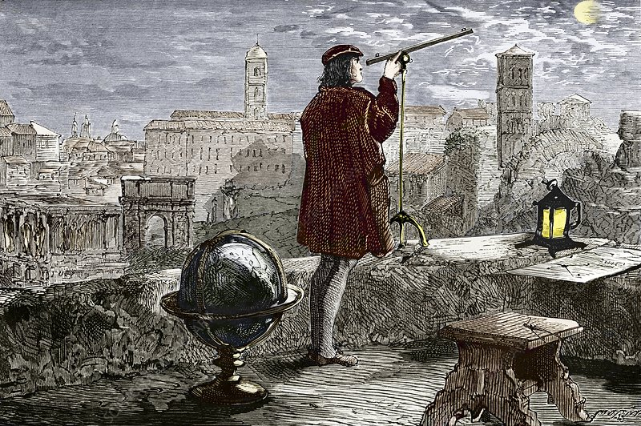

My second object is a picture of Nicolaus Copernicus observing the universe. He held the heliocentric theory that “the sun is the center of the whole universe” (Nicolaus Copernicus, 2019). On the contrary, people used to believe in geocentrism which considers the Earth as the center of the universe.

I choose this object because the heliocentric theory challenged the general public’s scientific belief and brought about tremendous impact at the time. Geocentrism had existed for fifteen hundred years, proven again and again by top scientists and declared as truth by most religions. It was a dramatic shock when the heliocentric theory came out, and most scientists refused to believe it. The geocentric model required up to forty “auxiliary circles,” a complete mess given the elegance of most models in physics; on the contrary, heliocentrism appeared surprisingly accurate and simplistic in describing the motions of the solar system. Thanks to more than a thousand years of experience and development in optics before Copernicus’ work, he could discover minor discrepancies between observations and theories through more accurate telescopes to work out his new theory. The fact that the geocentric model fell short in its predictive power compared to heliocentrism caused an increasing number of scientists to abandon it. Hence, new scientific knowledge was able to modify established beliefs when alternative models are developed.

Copernicus' discovery directly contradicts past knowledge. However, heliocentrism was abandoned later when scientists proved that the Sun was not the center of universe using radiotelescopes that peered into deep space never before accessible to optic telescopes. More accurate models always outweigh the inferior ones. Science and technology will develop and upgrade continuously; consequently, newer and more effective technology will replace previous technologies when technology develops and new findings are proposed.

**Object 3**: A Genetically Modified (GM) Food (*Plants modified to boost photosynthesis produce greater yields, study shows*, 2016)

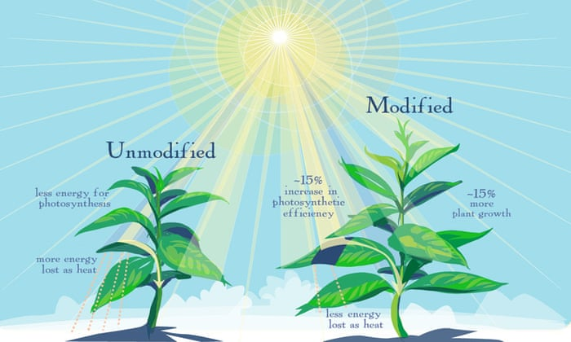

My third object is a picture of a Genetically Modified food. Genetic Editing technology prevails in recent years in many agricultural applications. GM plants have been proven to yield more while consume less. They are also more robust against pests, promoting the growth of plants on a large scale. However, people’s perspective on the GM plants are quite negative. They thought that GM foods may cause allergic reactions or even cancer.

Because people still have limited knowledge of GM plant, they may instinctively reject new things for the concern of threats to their health. However, the benefits of GM food have already led to widespread adaptation especially in the production of animal feeds and biofuel. Although GM labels are strictly enforced wherever GM foods are sold, their growing presence reflects consumers’ gradual shift in opinions.

However, the case of GM food is a bit special. Consumers have the reason of not accepting the GM food, because scientists have proposed that some long-term effects are still unknown. The side effects of technology are sometimes unavoidable, so any new technology should undergo extensive tests to assure its safety before everyday people can safely consume it. The brief history of GM foods means that their long-term effects are still under research. Few published works covered the entirety of a human lifetime. Therefore, the popularization of GM food should still be conservative. In the meantime, grocery stores that specialize in “organic” produce have enjoyed great success thanks to people’s skepticism of GM technology. Consequently, new scientific knowledge may not change established values.

Word count: 944

**References**

1. The screenshot of my Python program and the output.

2. Anon, 2021. *Nicolaus Copernicus, Polish astronomer*. Available at: https://www.paybanks.ga/ProductDetail.aspx?iid=50742618&pr=59.99 [Accessed September 15, 2021].

3. Anon, 2016. Plants modified to boost photosynthesis produce greater yields, study shows. *The Guardian*. Available at: https://www.theguardian.com/science/2016/nov/17/plants-genetically-modified-to-boost-photosynthesis-produce-greater-yields-study-shows [Accessed September 15, 2021].